OS LAB 14

TASK:

FIRST DIRECTORY MOD

MAKE FILE CODE:

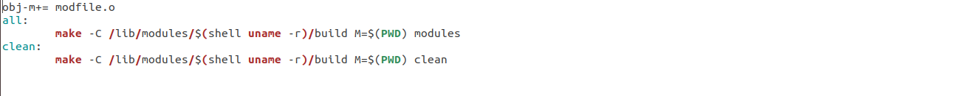
GEDIT FILE CODE:

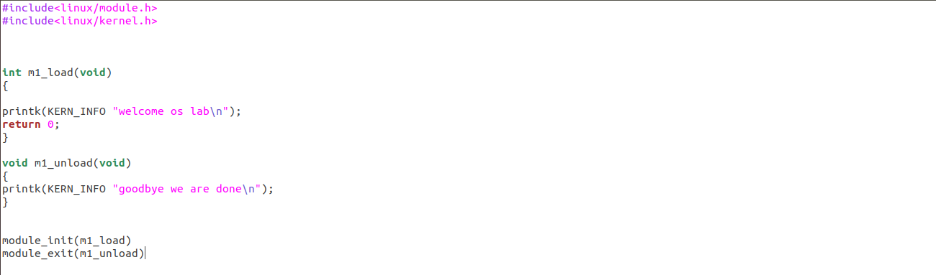

OUTPUT:

SECOND DIRECTORY MOD 1:

MAKE FILE CODE:

GEDIT FILE CODE:

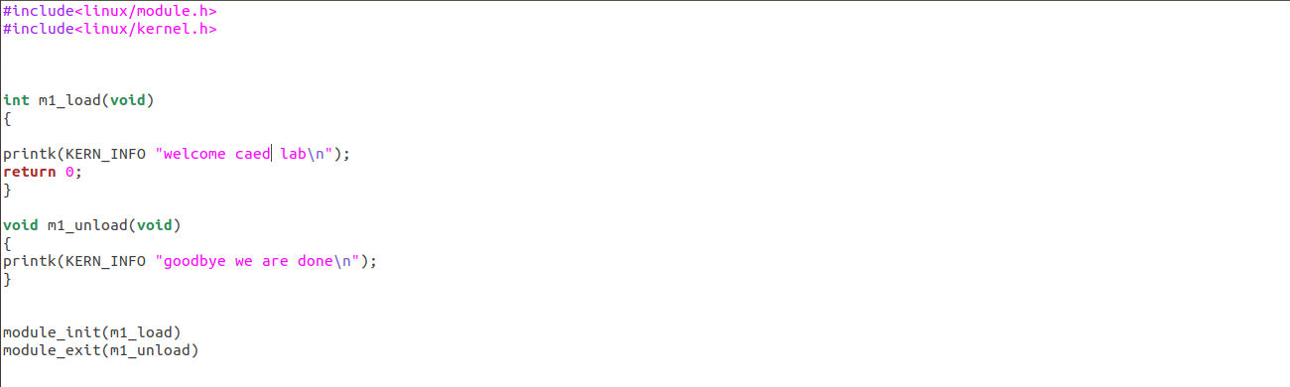

OUTPUT:

